Ahmad Hawwari

Diaa sharqawi

Dos project

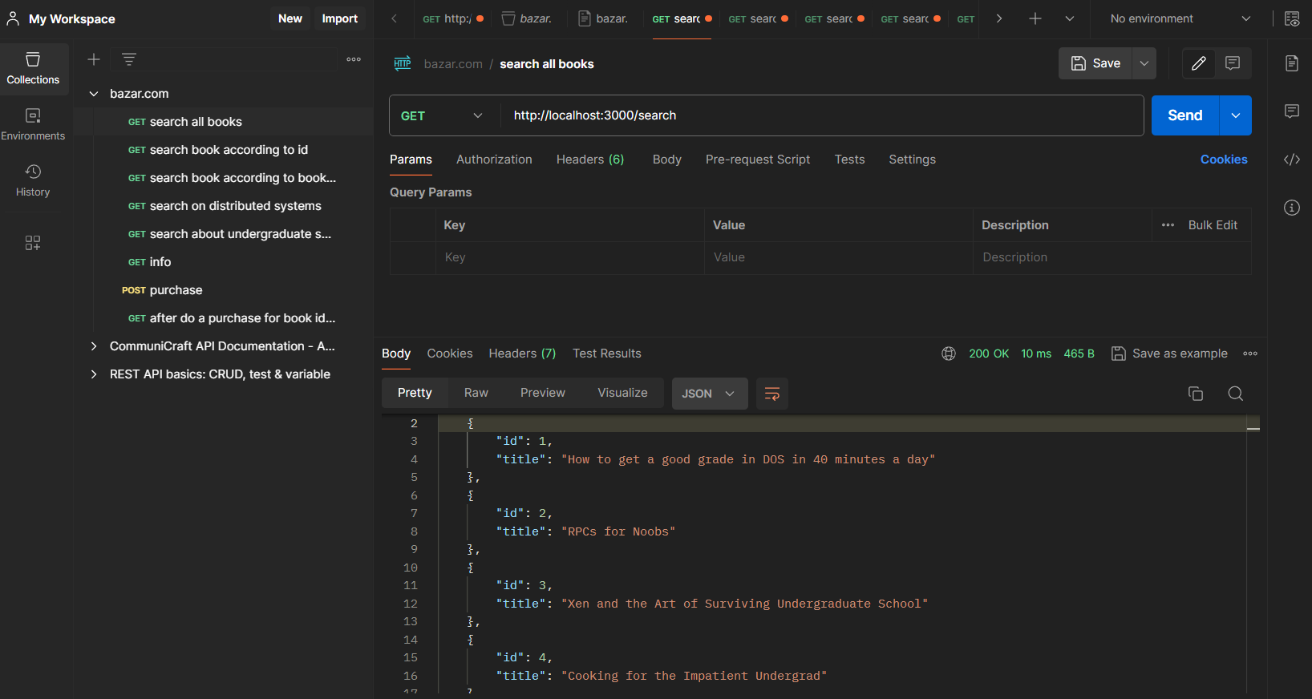

As you see here we have 3 servers with 3 containers

The request above it was for port 3000 who is the port of frontend server and the catalogs or books exist for our code in catalog server so the 2 servers can communicate because of yml file who connect the containers.

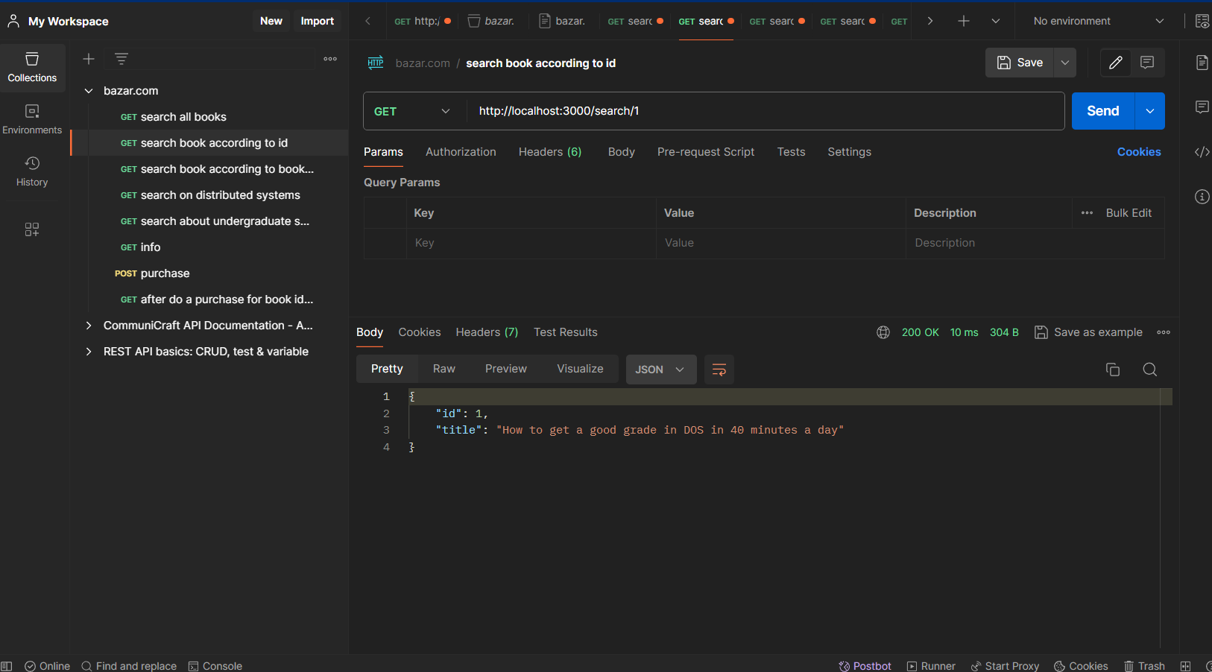

This photo request a specific book who is the id =1.

The request is for frontend server and the it pass it to catalog server … catalog server back the response to the frontend server as above photo .

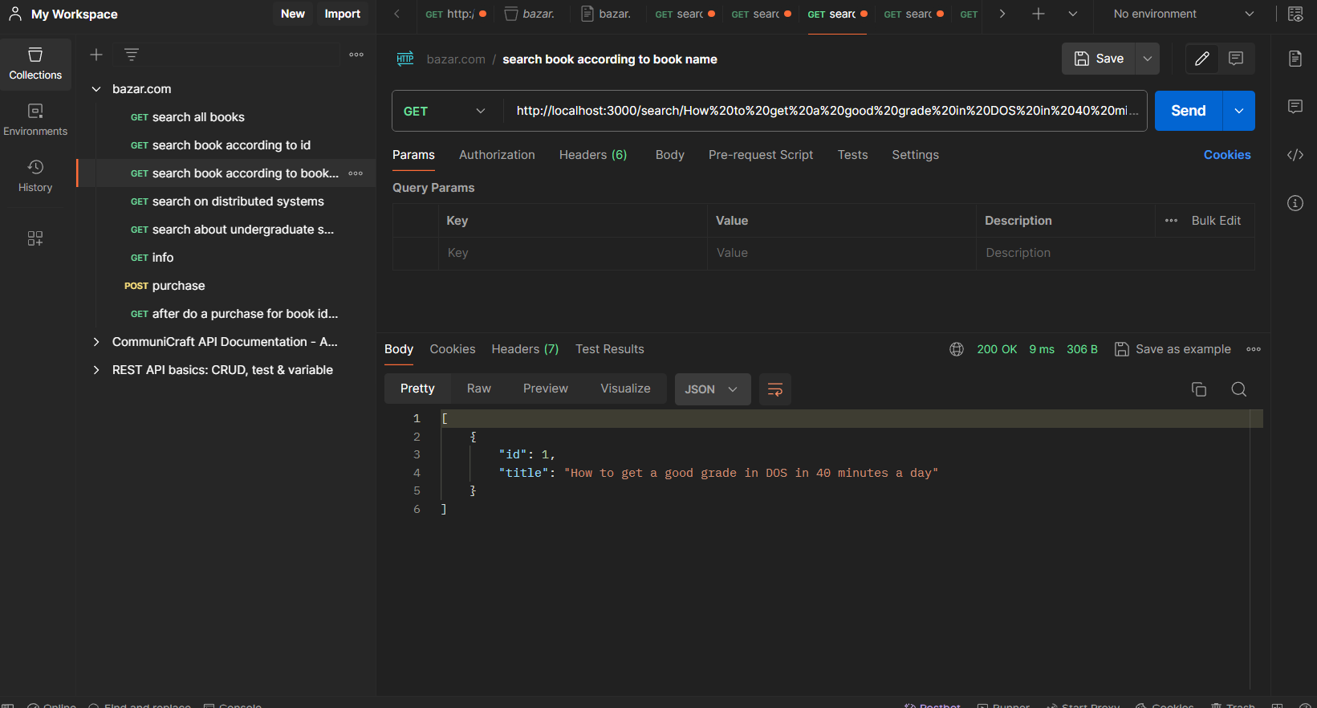

Here is the request for a specific book according to its title .

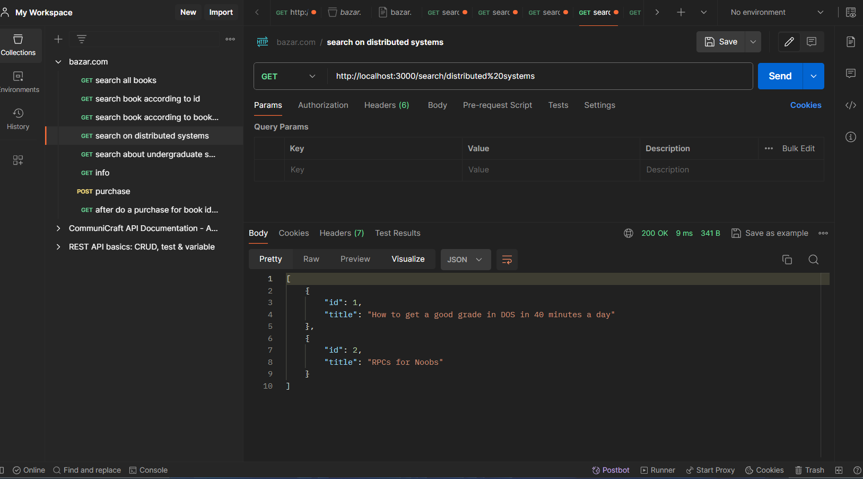

Here is a search about books related to distributed systems

The result as the above photo .

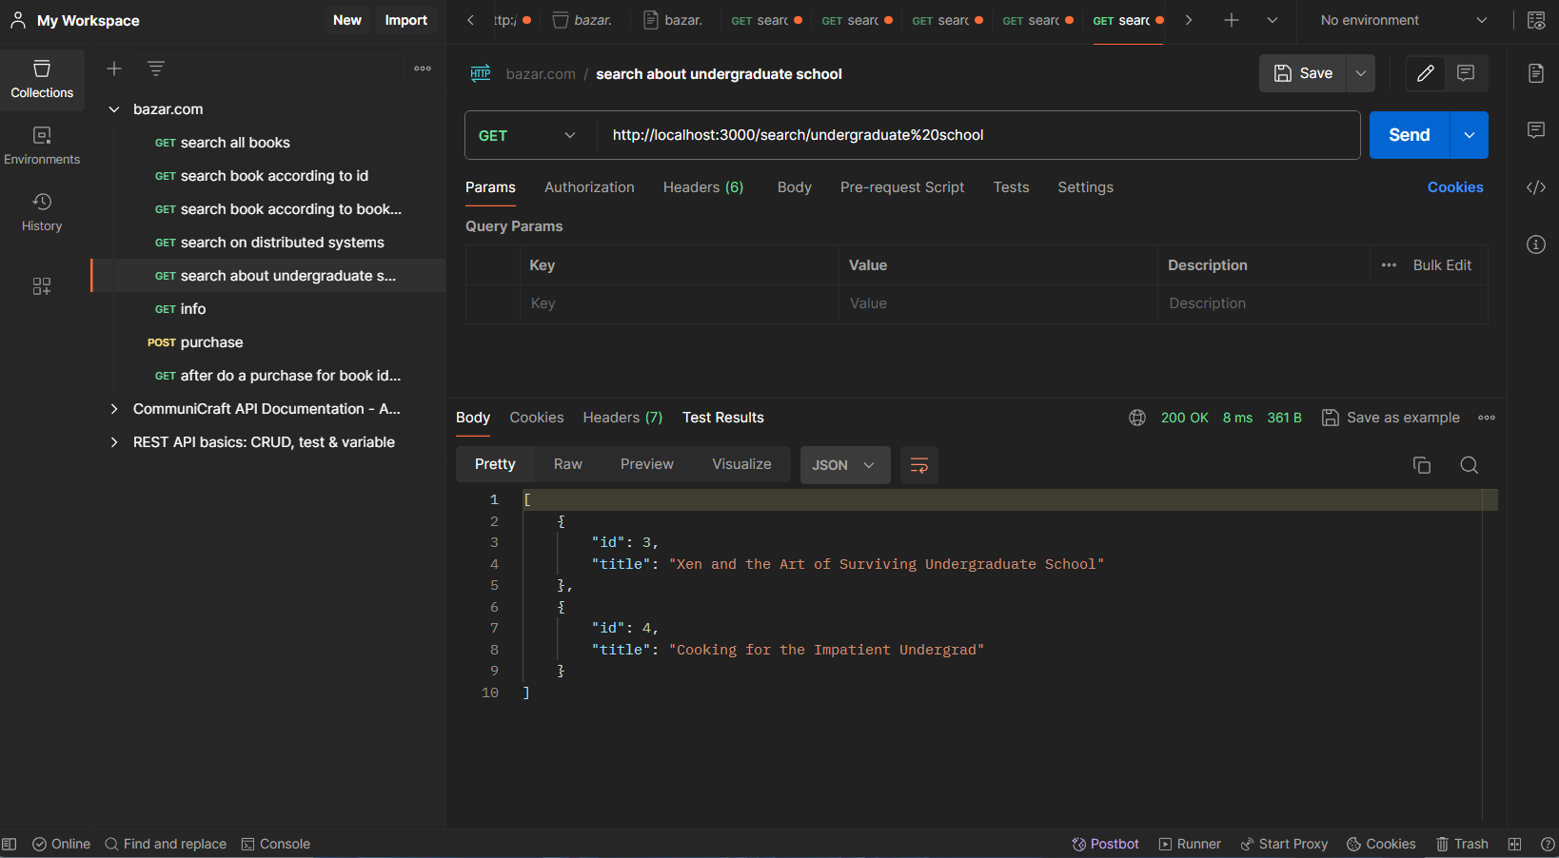

Here is a search about books related to undergraduate school

The result as the above photo .

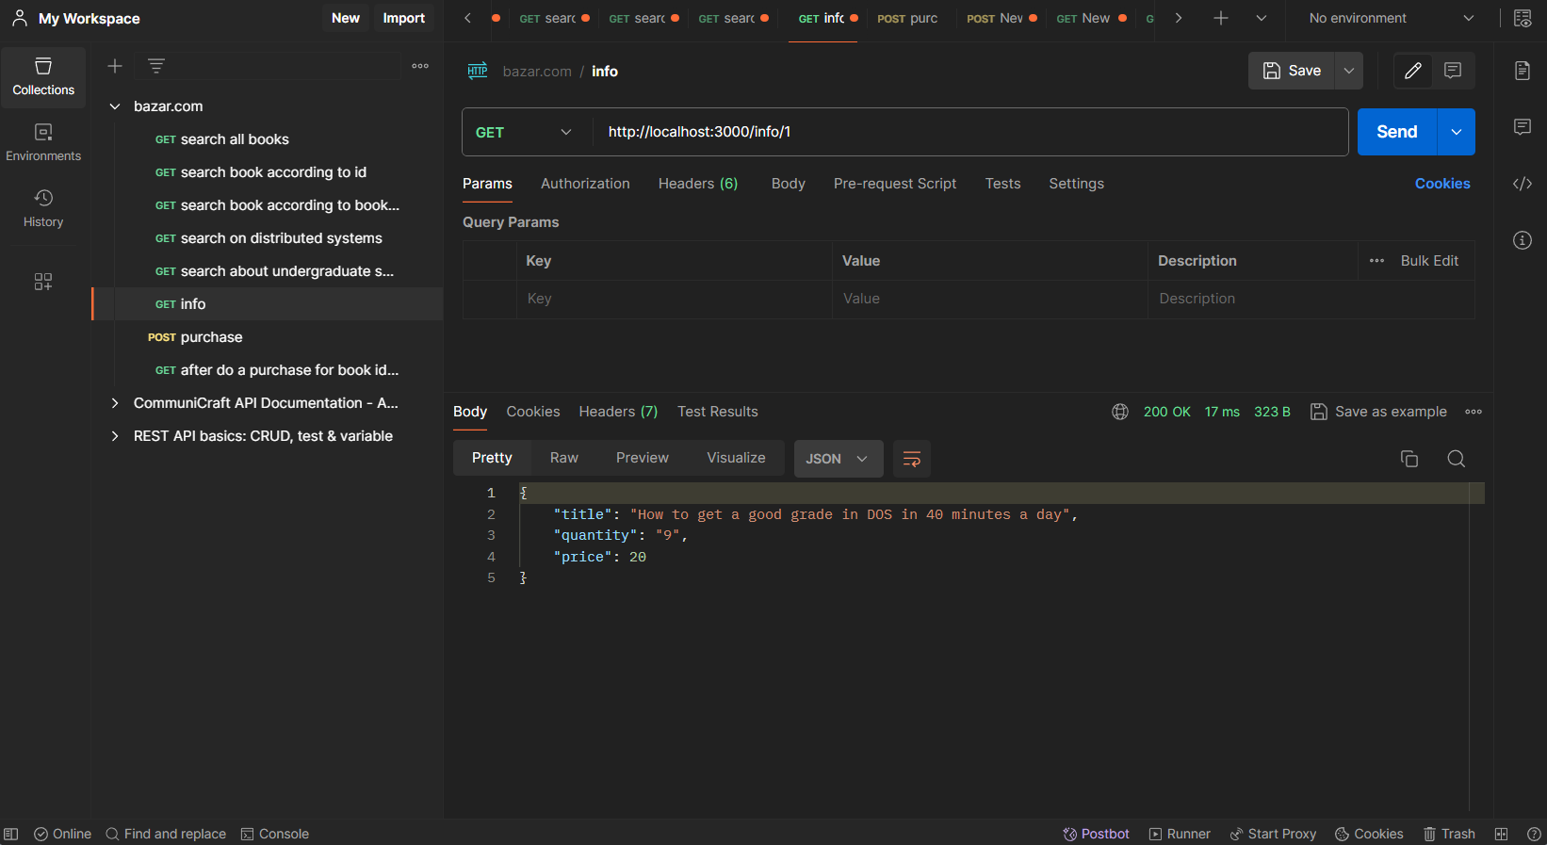

So now we see the information about a specific book with quantity number =9.

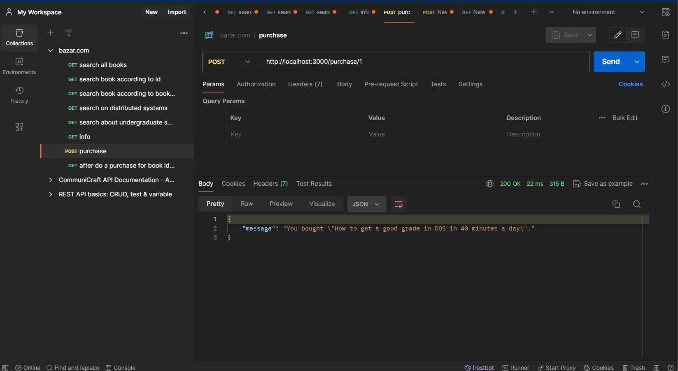

Here we do a post request for purchase with id =1 it’s the same above with the quantity =9.

So now after that the quantity must decrease by one as follows:

